

**Start with why?**

**Title – narrow the focus / give us a teaser / clue**

**Pitch – this is your identity. It attracts the people who you want to listen and repels those for whom you are not a match. Own it! Attract your tribe.**

The “Worldview” Template

I believe that ______________________________________________________________________

OR : I believe that doing _____________________________________________________________

Is (key?, instrumental?, a must?) _______________________________________________________

To/for (success?, overcoming x?, achieving x?) ___________________________________________

In (this and/or that endeavour) ________________________________________________________

Have you ever gone through change in your personal life or at work and thought to yourself “there must be a better way to do this?” Welcome to OnChange, the podcast that explores change - that works – and the people who make it happen. And now, from the Gold Studios, here’s your host, Petro du Pisani.

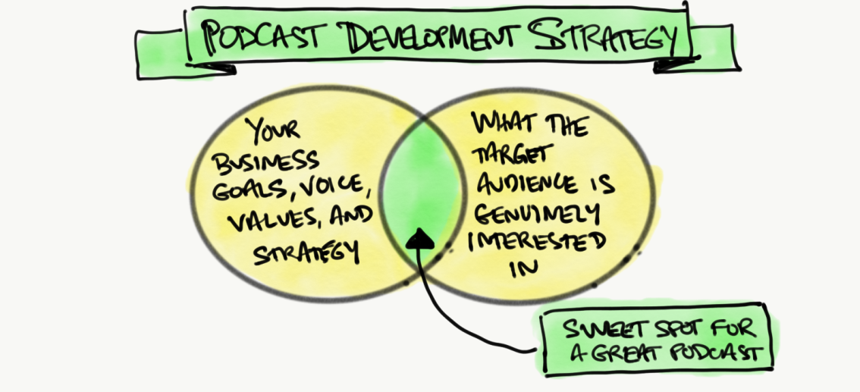

1. **Create great content that is timeless.** *Create great content that people want to revisit and share. Stories work well.*
2. **Start thinking about the questions you want to answer.** *Begin answering the questions people are looking to find answers to.*
3. **Begin to welcome a broader geographic.***Think about how you engage an international audience.*
4. **Write good titles and descriptions.** *Be aware of how your text reads in various podcast apps.*
5. **Ensure your cover art is a doorway.** *Your cover art is your first impression to listening – give visual promise!*

The “big rule” here is what you want simple graphics that will be easy to read on a small screen.

This means:

1. Less is more.
2. No more than five words on your artwork. Anything more and the font size you’ll have to use to fit everything in will be too small to easily read on a mobile device.
3. No “fancy” fonts. Avoid handwritten and “cursive” style fonts that make people work to figure out what you’re trying to say.
4. No dark text on a dark background (or light text on a light background).
5. No text on top of a photograph or complicated background.